Spatial Analysis of Live Facial Recognition Deployments in London, 2025

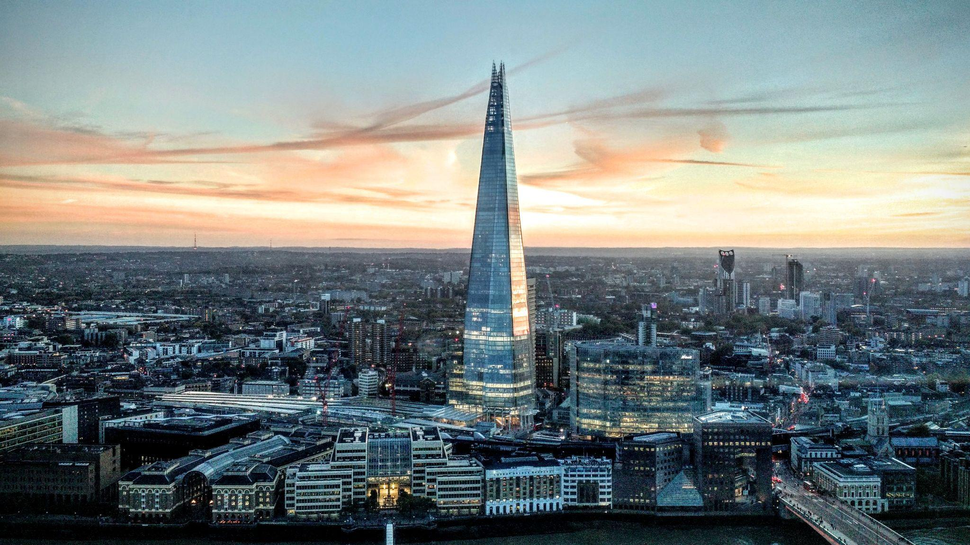

GIS-centered analysis of live facial recognition deployments by the Metropolitan Police, set against stop & search statistics and metrics of socio-economic deprivation.

## 

### Project repository: github.com/barneysolly/london-lfr-surveillance

## 

## 

## Barney Solly

23/01/2026

## Contents

**Executive Summary 3**

**Introduction 4**

**Research Question 5**

**Data 5**

**Methods 5**

**Limitations and Scope 6**

**Findings 7**

**Figures and Tables 9**

**Interpretations 13**

**Policy Implications & Conclusion 13**

**Bibliography 15**

## 

## 

## 

## 

## 

## Executive Summary

This report analyses the geographic distribution of live facial recognition (LFR) deployments by the Metropolitan Police in 2025. It uses Police and Home Office data to map LFR deployments against stop & search levels and deprivation measured by the Index of Multiple Deprivation (IMD). The granularity of the mapping and analysis is at the Lower Level Super Output Area (LSOA) level.

This analysis is important because current deployments of LFRs are contentious, and there is a lack of specific regulations overseeing their deployment.[1] Understanding where deployments are occurring and how they co-locate with stop & search statistics and socio-economic deprivation is useful in determining risks and benefits of LFR deployment.

Findings show a strong positive correlation between the location of LFR deployments and stop & search incidents across London. 74.35% of LFR deployments occur in LSOAs that are in the highest decile for stop & search incidents. Analysis also shows that 64.3% of LFR deployments in 2025 occur in LSOAs that rank in the top 30% for levels of socio-economic deprivation. The results show a slight correlation between LFR deployments and LSOAs that have seen an increase in stop & search incidents between 2023 and 2025.

The report includes three maps and an analysis of the data used to generate the maps. The first map (Figure 1) tracks 2025 LFR deployments against 2025 stop & search data. The second map (Figure 2) charts the change in stop & search levels between 2023 and 2025 against 2025 LFR deployments. The third map (Figure 3) charts LFR deployments against 2019 IMD data for each LSOA.

The conclusions drawn are that LFR deployments are heavily concentrated within areas already experiencing high levels of surveillance-intensive stop & search policing, and within areas that also rank amongst the most deprived areas in England.

The report conceptualises LFR as surveillance-intensive and draws parallels with elements of stop & search. The report then draws on academic discourse that outlines how surveillance-intensive policing can entrench inequality. It also draws on discourse concerning the fact that low-income demographics tend to view facial recognition in policing as more concerning than the baseline level for the general population.

The report concludes that the concentration of LFR deployments in areas with high stop & search activity may be disproportionate due to the cumulative nature of policing in the area. It also concludes that the concentration of LFR deployment in areas with high socio-economic deprivation risks worsening the relationship between communities in that area and their police force.

## Introduction

Live Facial Recognition (LFR) is used to scan the faces of the public and match against a temporary “watchlist” of individuals that are of interest to the police.[2] The technology is built on AI algorithms that translate identifying features into a set of numbers and use this “facial template” to calculate the likelihood that two images of a face are from the same person.[3]

Trials of the technology began in 2016. As of November 2025, over 13 police forces have trialled or deployed LFR in some way, a number which has more than doubled in a year.[4] There is tension between those who point towards its proven ability to catch dangerous criminals, and others who argue that the technology poses a threat to “rights to privacy, freedom of expression, and freedom of assembly.”[5]

Statistics released in January 2026 have pointed towards London’s murder rate reaching an 11-year low. Met Police Commissioner Sir Mark Rowley cited LFR as a factor in the fall in homicides.[6] Other factors, such as a reduction in the use of stop & search, have also been identified as coinciding with the drop in murder rates.[7]

In the same month as these murder statistics were released, the High Court is due to hear a case brought against the Metropolitan Police by Shaun Thompson and Big Brother Watch. After being misidentified by LFR in 2025, Mr Thompson described the experience as "intimidating" and "aggressive" and as “Stop and Search on Steroids.”[8]

Connections to stop & search provide this report’s base for comparison and investigation. A drop in stop & search has coincided with a fall in homicide, yet those experiencing LFR failures have equated the two tactics. Furthermore, both LFR and stop-and-search can be interpreted as surveillance-intensive police tactics.

Also relevant to this report are the concerns about existing biases in policing being propagated through the use of LFR. Certainly, there are groups in society that view LFR with more suspicion. Work by the Ada Lovelace Institute found that black and Asian people, as well as those on lower incomes, were more likely to view facial recognition in policing with concern when compared to the general population.[9]

This report analyses the spatial connections between LFR deployments and stop & search activity in London. It also explores whether LFR deployment is concentrated in areas associated with lower income.

## Research Question

Is live facial recognition being deployed in areas that already experience higher levels of stop & search policing and socio-economic disadvantage?

## Data

The datasets used in this report were collected from a range of publicly accessible sources.

Deployments of LFR were obtained from the Live Facial Recognition Technology page on the Metropolitan Police website. This page provides links to PDFs of LFR deployments between 2022 and 2026 (to date), separated by year. 2025 was selected to provide the most up-to-date, complete set of LFR deployments over a single year. This was deemed to be a reasonable period of analysis since it captures seasonal differences in policing trends.

Stop & Search statistics were obtained from Data.Police.UK. The specific datasets used in this report were Stop & Search statistics for January to November 2023 and January to November 2025. At the time of this report’s writing, stop & search statistics for December 2025 had not been released. December 2023 was omitted from the data to allow for consistency when generating a change-over-time analysis.

Socio-economic deprivation was measured using the English Index of Multiple Deprivation (IMD) 2019, published by the Ministry of Housing, Communities and Local Government. IMD 2019 was selected to ensure consistency with Lower Layer Super Output Area (LSOA) 2011 boundaries, which are used throughout the spatial analysis.

LSOA boundary data for London were obtained from the Office for National Statistics Open Geography Portal. The 2011 boundaries were chosen as they align with the stop & search data.

## Methods

Stop & search records were cleaned and then combined across individual monthly files for each of the periods (Jan-Nov 2023, Jan-Nov 2025).[10] Latitude and longitude coordinates were converted to point geometries and encoded using a common coordinate reference system for such data (EPSG 4326). Each datum was spatially joined inside LSOA boundaries and aggregated so that a count of stop & search incidents per LSOA area could be established. Change-over-time analysis was achieved by subtracting the 2023 stop & search data from the 2025 data for each LSOA to calculate the absolute difference.

Data for Metropolitan Police deployments of LFR in 2025 was cleaned, and street names were geocoded to connect each deployment with a coordinated position.[11] Manual geocoding using online tools was used for deployments that failed to be geocoded using Python code. The coordinates were converted to point geometries and encoded using EPSG/CRS 4326. The deployments were mapped onto choropleth maps using their latitude and longitude coordinates, and were also spatially joined to LSOA boundaries to generate statistics about the number of deployments per LSOA. LFR locations were compared with LSOAs in the highest decile of stop & search activity, as well as with areas experiencing increases or decreases in stop & search over time.

Socio-economic data represented by IMD deciles connected to LSOAs nationwide were obtained and filtered to only include London locations.[12] This data was merged with a dataset containing LFR deployment and stop & search counts to generate statistics. IMD deciles were mapped using graduated symbology with LFR deployments overlaid.

All spatial analysis and mapping were conducted using Python (Pandas, GeoPandas, Shapely, GeoPy) and QGIS. Code and data processing scripts are available on GitHub: github.com/barneysolly/london-lfr-surveillance

## Limitations and Scope

This analysis only examines the spatial connection between LFR deployment, IMD decile, and stop & search. In analysing change-over-time specifically, this report does not seek to suggest a causal relationship. Rather, this analysis seeks to understand how these two forms of polling co-exist spatially.

Additionally, this report acknowledges that stop & search is only one specific method of policing and will not completely reflect the spread of activity across London. Stop & search has been applied to the spatial analysis due to the surveillance-intensive elements that it shares with LFR.

This analysis uses the Index of Multiple Deprivation (IMD) as an area-level measure of socio-economic disadvantage. While the Ada Lovelace Institute’s research focuses specifically on income, IMD captures multiple dimensions of deprivation, including income. As a result, while IMD does not directly track individual income, its inclusion of income deprivation allows for a level of analysis against the institute’s findings.

2011 LSOA boundaries were used, instead of updated boundaries, to ensure alignment with stop & search data that is still published using these boundaries. Accordingly, the IMD deprivation dataset used was from 2019, as this was the last IMD publication to use the 2011 boundaries. In this context, spatial consistency was judged to have a higher priority than obtaining the most recent deprivation data.

Also of note is the slight misalignment between stop & search and LFR deployment timelines due to the partial-year date (Jan-Nov 2025) for stop & search. This is not judged to substantially affect the findings, as the analysis focuses on spatial patterns rather than yearly totals.

A further limitation is that the publicly available LFR records only provide street-level precision. Whilst care has been taken to ensure that the geocoding is accurate, the precision is inherently impacted by the length of the street. Furthermore, aggregating point-level stop and search incidents to LSOAs introduces the modifiable areal unit problem (MAUP), whereby results may vary with the choice of spatial unit. For the purposes of this report, the granularity and precision were deemed satisfactory.

Finally, this analysis is limited to London and should not be generalised to other areas without careful account being taken of the inherent differences between geographies.

With these limitations in mind, the following section presents the results of the spatial analysis.

## 

## 

## 

## 

## 

## 

## Findings

Results show that LFR deployments are highly concentrated in LSOAs that also experienced high stop & search activity in 2025.

Figure 1 highlights the concentration of LFR deployments in areas experiencing high stop & search activity in 2025. As shown in Table 1, 74.35% of deployments occurred in LSOAs that were in the top 10% for stop & search activity. 84.25% of LFR deployments were located in LSOAs that experienced the top 20% of stop & search incidents.

Results show a slight connection between LFR deployments and LSOAs where stop & search incidents increased between 2023 and 2025.

Figure 2 demonstrates that LFR deployments have a slight weighting towards LSOAs where stop & search is increasing. Table 1 displays that 54.78% of LFRs occur in LSOAs where stop & search increased between 2023 and 2025. 43.91% of LFR deployments occur in LSOAs where stop & search fell over the same period. 1.3% of LFRs occur in LSOAs where stop & search remained consistent over the period.

Results show a strong connection between LFR deployments and LSOAs with a high level of socio-economic deprivation measured by IMD.

Figure 3 reveals the concentration of LFR deployments in LSOAs with a comparatively high level of deprivation. Table 1 indicates that 63.04% of LFR deployments occurred in LSOAs that were amongst the top 30% most deprived in England. 5.65% of deployments occur in LSOAs that exhibit the highest decile of deprivation.

## Figures and Tables

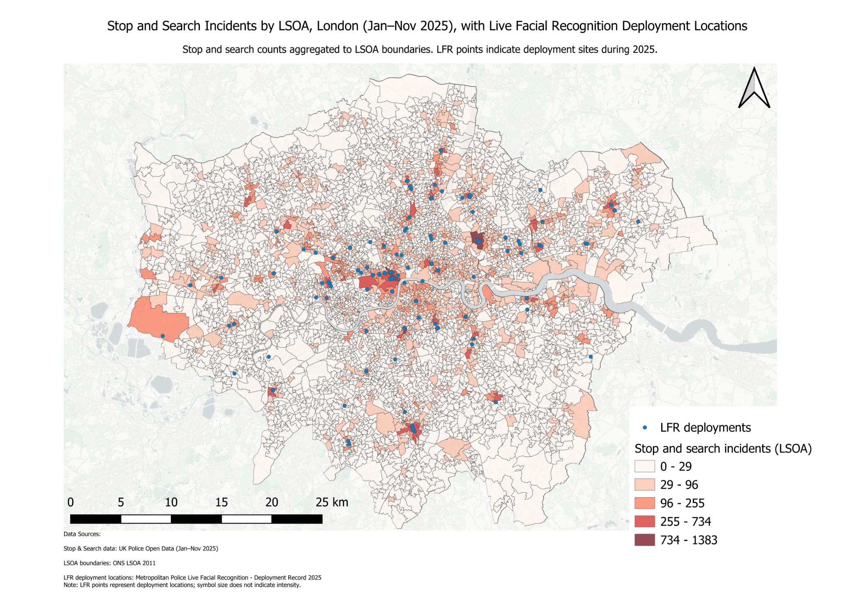

**Figure 1.** Stop and Search Incidents by LSOA, London (Jan–Nov 2025) with Live Facial Recognition deployment locations.

*Data sources: Home Office stop and search open data (2025); ONS LSOA boundaries (2011); Metropolitan Police Service live facial recognition deployment locations (2025). Map created by author using QGIS.*

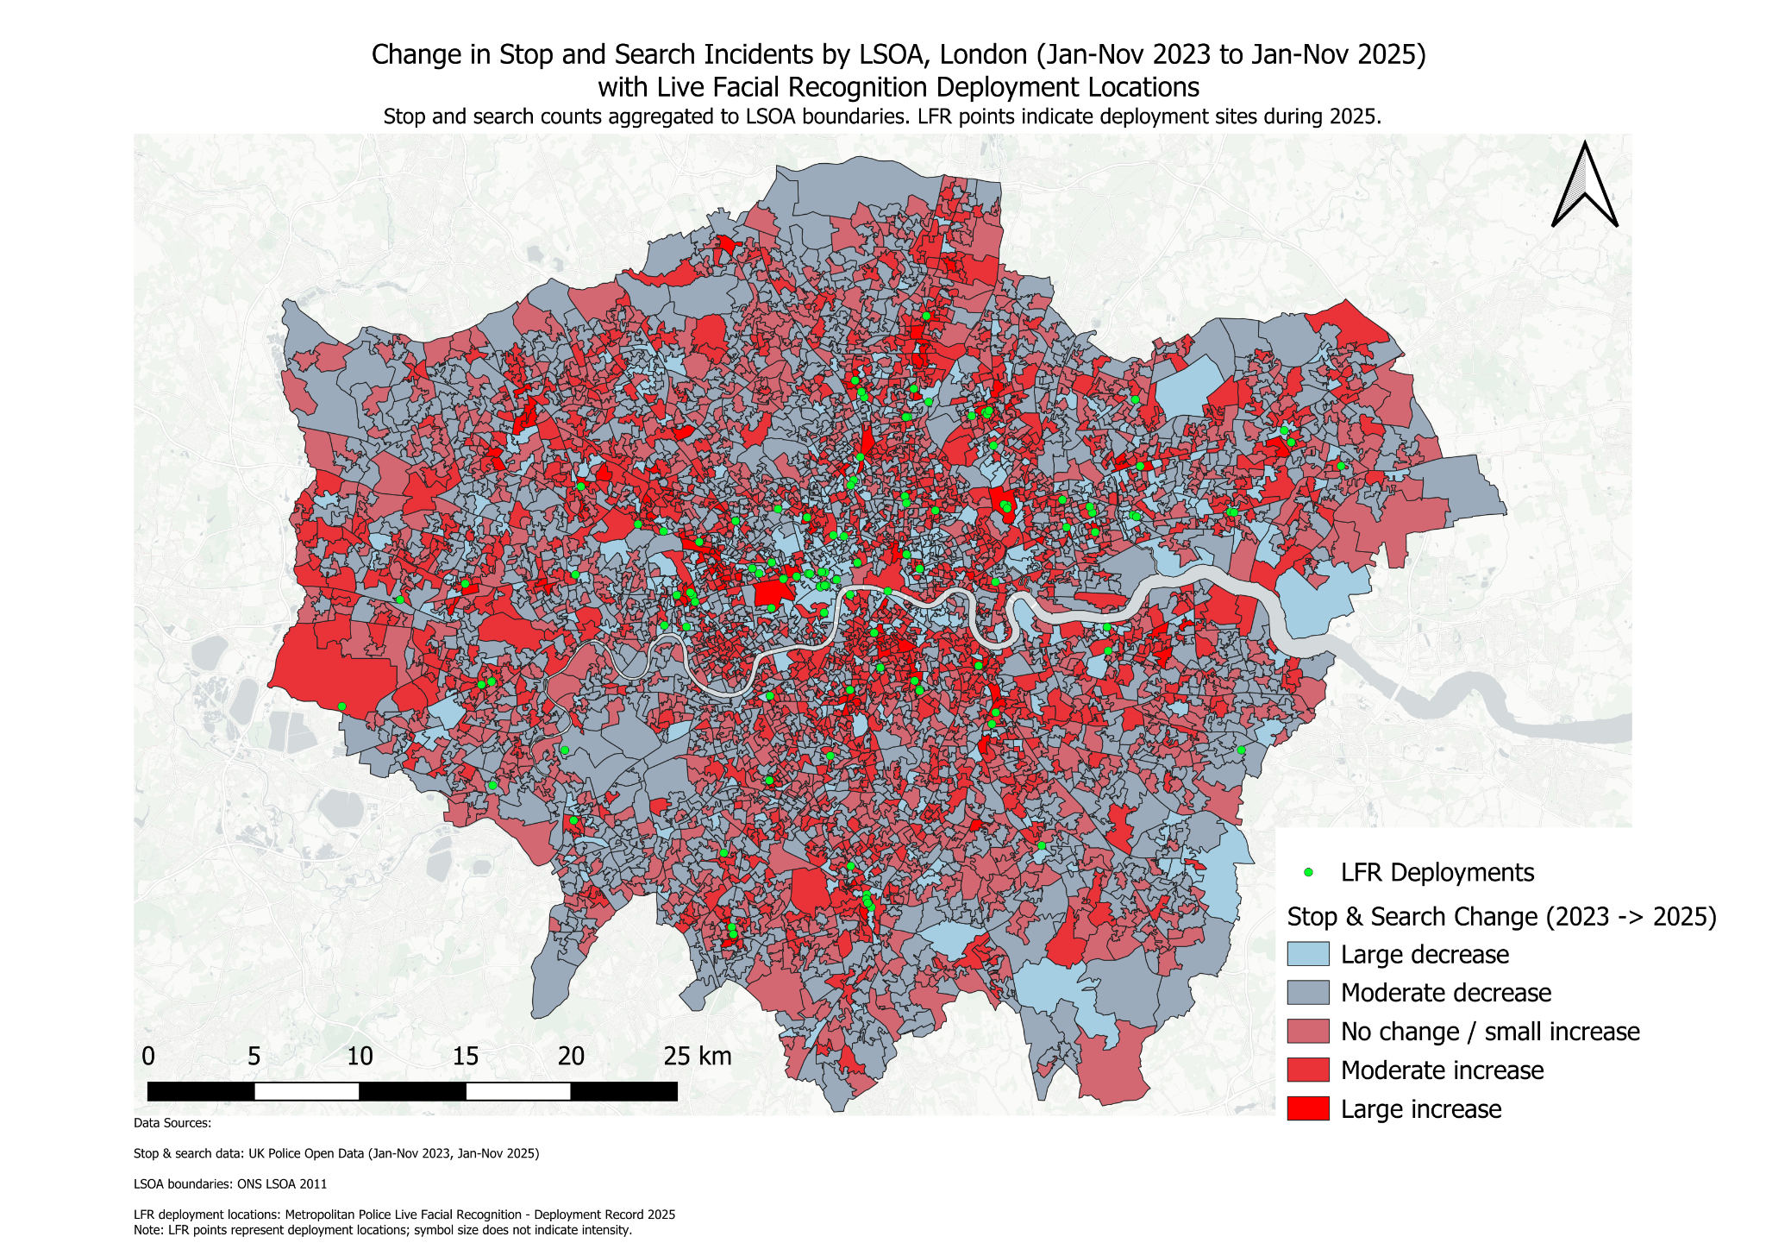

**Figure 2.** Change in Stop and Search Incidents by LSOA, London (2023–2025) with Live Facial Recognition deployment locations.

*Data sources: Home Office stop and search open data (2023, 2025); ONS LSOA boundaries (2011); Metropolitan Police Service live facial recognition deployment locations (2023–2025). Map created by author using QGIS.*

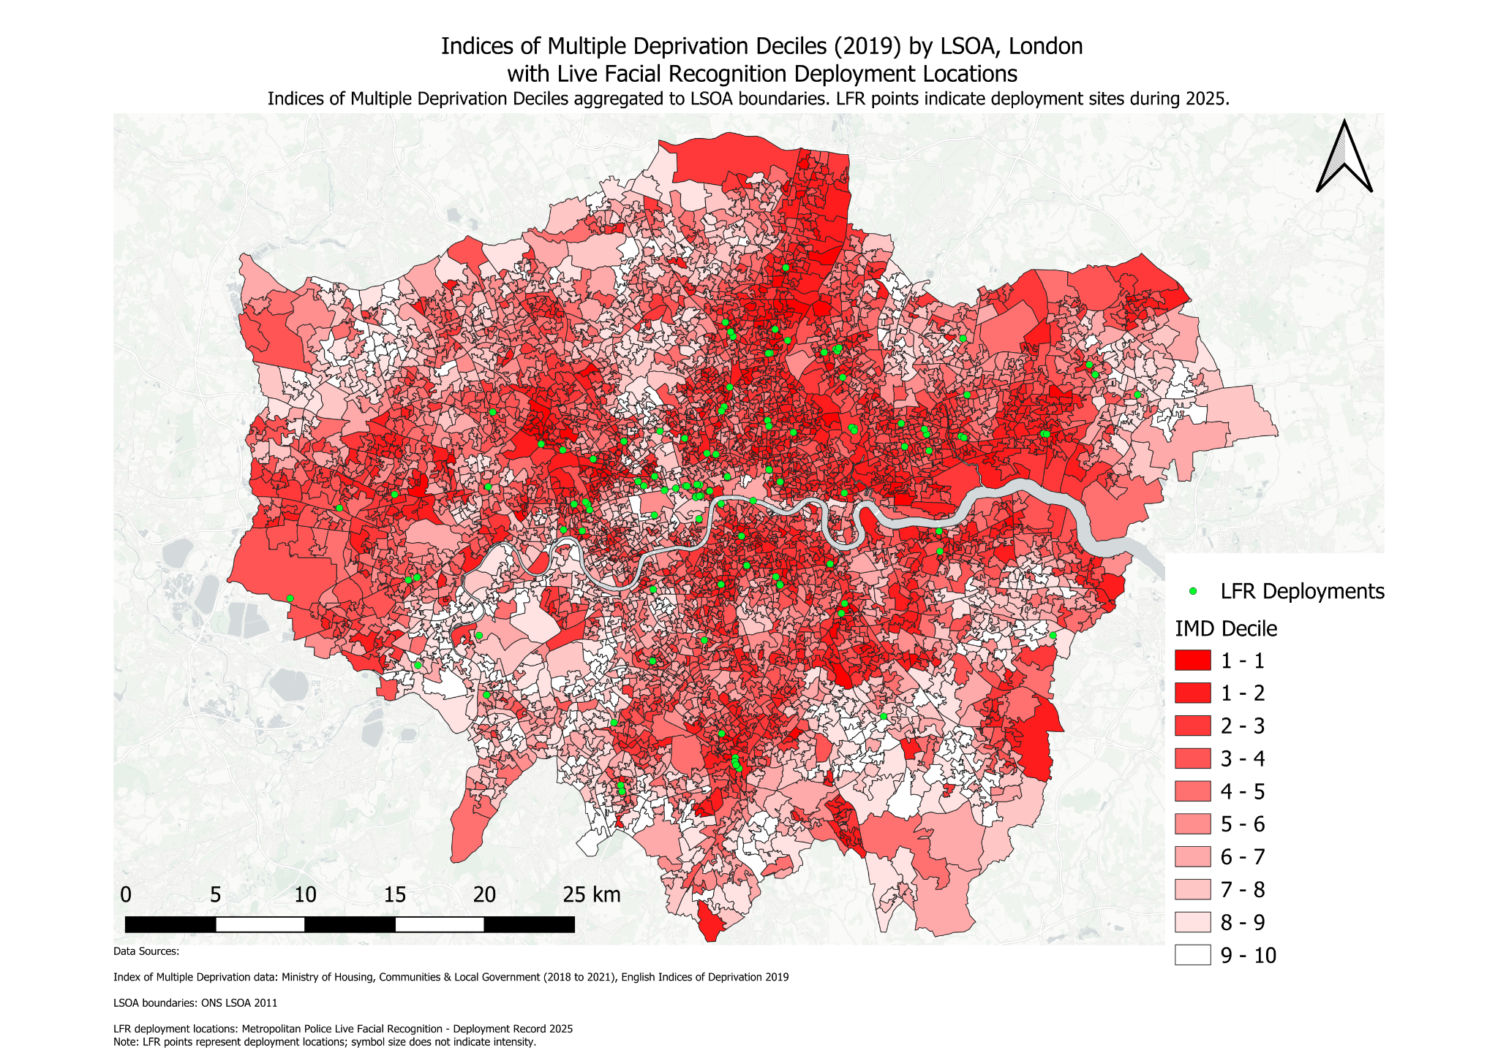

**Figure 3.** Index of Multiple Deprivation (IMD) by LSOA, London, with Live Facial Recognition deployment locations.

*Data sources: Ministry of Housing, Communities & Local Government (IMD 2019); ONS LSOA boundaries (2011); Metropolitan Police Service live facial recognition deployment locations (2023–2025). Map created by author using QGIS.*

| **Measure** | **Result** |
| --- | --- |
| **Total number of LFR deployments analysed** | **230 deployments** |
| **Stop and search threshold defining the top 10% of LSOAs** | **More than 53.6 stop and search incidents** |
| **Number of LFR deployments in top 10% stop and search LSOAs** | **171 deployments** |
| **Percentage of all LFR deployments in top 10% stop and search LSOAs** | **74.35%** |
| **Stop and search threshold defining the top 20% of LSOAs** | **More than 32.0 stop and search incidents** |
| **Number of LFR deployments in top 20% stop and search LSOAs** | **194 deployments** |
| **Percentage of all LFR deployments in top 20% stop and search LSOAs** | **84.35%** |
| **Number of LFR deployments in LSOAs where stop and search increased (2023–2025)** | **126 deployments** |
| **Number of LFR deployments in LSOAs where stop and search did not change** | **3 deployments** |
| **Number of LFR deployments in LSOAs where stop and search decreased** | **101 deployments** |
| **Percentage of LFR deployments in areas with rising stop and search** | **54.78%** |
| **Percentage of LFR deployments in areas with no change in stop and search** | **1.30%** |
| **Percentage of LFR deployments in areas with falling stop and search** | **43.91%** |
| **Number of LSOAs in the most deprived decile (IMD)** | **107 LSOAs** |
| **Number of LSOAs in the three most deprived deciles (IMD)** | **1,606 LSOAs** |
| **Number of LFR deployments in the most deprived decile** | **13 deployments** |
| **Number of LFR deployments in the three most deprived deciles** | **145 deployments** |
| **Percentage of LFR deployments in the most deprived decile** | **5.65%** |
| **Percentage of LFR deployments in the three most deprived deciles** | **63.04%** |

**Table 1:** Summary statistics on the spatial relationship between Live Facial Recognition (LFR) deployment, stop and search activity, and area-level deprivation in London

## Interpretations

This section interprets the spatial distribution of LFR deployments against stop & search incidents and socio-economic deprivation.

The 2025 analysis (Figure 1) shows that LFR deployments are clustered in areas that are also experiencing high levels of stop & search. This suggests that LFR is part of a cumulative strategy of policing, where strategies are layered rather than used in isolation. This aligns with Metropolitan Police data that LFR was primarily deployed to “crime hotspots” which would intuitively already be heavily policed.[13]

Intense policing of crime hotspots brings risk. It may lead to areas experiencing a disproportionate level of policing that could limit the levels of trust and cooperation between police and the communities they serve. A recent article in the European Journal of Criminology cited stop & search – particularly the surveillance involved in the practice – as a “mechanism for reinforcing social inequalities”.[14] It is reasonable to judge that LFR delivers a surveillance burden at least similar to that of stop & search, given the scanning of every individual that comes into the Zone of Recognition.[15] A 2024 CETas report notes how this could have a stifling effect on the rights of free assembly.[16]

The change-over-time analysis (Figure 2) indicates that LFR deployments occur in areas experiencing both increases and decreases in stop & search activity between 2023 and 2025. However, the slight weighting towards areas that have experienced an increase in stop & search reinforces the interpretation that LFR is part of a layered approach.

Furthermore, communities experiencing the highest levels of LFR deployments in London are also experiencing higher levels of socio-economic deprivation (Figure 3). The Ada Lovelace Institute's scholarship is useful in revealing that, whilst lower-income communities do see the facial recognition as potentially beneficial, they also have a higher likelihood of being concerned about its use when compared to the general population.[17] The fact that the communities experiencing the majority of the LFR deployments are also the communities more likely to be concerned by the technology should be taken into account. These findings should be interpreted cautiously, as IMD is not a direct measure of income, though it does incorporate income as a weighted constituent of its value.

## Policy Implications & Conclusion

If implemented appropriately, LFR could benefit cohesion and trust by reducing the number of criminals on the streets. However, if implemented incorrectly, it risks further damaging relationships between communities and their police.

This report concludes that concentrating LFR deployments in areas already experiencing high stop & search activity may be disproportionate (proportionality being a key requirement for deployments).[18] Not only are the effects of multiple deployments cumulative,[19] but they are layered on top of pre-existing policing strategies.

The report also concludes that concentrating LFR deployments in areas with high levels of socio-economic deprivation increases the risk of mistrust due to a slightly higher level of concern about LFR technology compared to the general population.

Whether LFR in its current application is legal is contentious. This report makes the arguement that, in their current practice, deployments by the Metropolitan Police could be considered disproportionate.

What is clear is that concentrating LFR deployments on areas already burdened by deprivation and experiencing high levels of stop & search risks further entrenching the inequalities that contribute to that area being a crime hotspot in the first place.

## Bibliography

Agnew-Pauley, Winifred, Caitlin Elizabeth Hughes, and Alex Stevens. ‘A Realist Review on the Police Use of Stop and Search Powers’. *European Journal of Criminology* 22, no. 3 (2025): 346–74.<https://doi.org/10.1177/14773708241290593>.

Big Brother Watch Team. ‘Met Police Face Major Legal Challenge over Use of Live Facial Recognition Technology’. 22 July 2025.<https://bigbrotherwatch.org.uk/press-releases/met-police-face-major-legal-challenge-over-use-of-live-facial-recognition-technology/>.

Birtwistle, Micheal, and Nuala Polo. *An Eye on the Future*. Ada Lovelace Institute, 2025.<https://www.adalovelaceinstitute.org/policy-briefing/an-eye-on-the-future/>.

Data.Police.UK. ‘Stop and Search Data Metropolitan Police’. CSV. November 2023.<https://data.police.uk/data/>.

Data.Police.UK. ‘Stop and Search Data Metropolitan Police’. CSV. November 2025.<https://data.police.uk/data/>.

Dodd, Vikram. ‘London’s Murder Rate Drops to Lowest in More than a Decade’. *The Guardian*, 12 January 2026.<https://www.theguardian.com/uk-news/2026/jan/12/london-homicide-rate-drops-to-lowest-in-more-than-a-decade>.

Dodd, Vikram. ‘Stop and Search Study in England and Wales “Casts Doubt” on Effectiveness’. *The Guardian*, 21 August 2024.<https://www.theguardian.com/law/article/2024/aug/21/stop-and-search-study-in-england-and-wales-casts-doubt-on-effectiveness>.

Edwards, Charlotte. ‘Human Rights Regulator Criticises Met’s Use of Facial Recognition Cameras’. *BBC News*, 20 August 2025.<https://www.bbc.co.uk/news/articles/c1kzgx4v2pko>.

Home Office. *Consultation on a New Legal Framework for Law Enforcement Use of Biometrics, Facial Recognition and Similar Technologies (Accessible)*. 2026.<https://www.gov.uk/government/consultations/legal-framework-for-using-facial-recognition-in-law-enforcement/consultation-on-a-new-legal-framework-for-law-enforcement-use-of-biometrics-facial-recognition-and-similar-technologies-accessible>.

Home Office. *Guidance - Police Use of Facial Recognition: Factsheet*. 2025.<https://www.gov.uk/government/publications/police-use-of-facial-recognition/police-use-of-facial-recognition-factsheet>.

Jessup, Sonja. ‘“Facial Recognition Tech Mistook Me for Wanted Man”’. *BBC News*, 6 August 2025.<https://www.bbc.co.uk/news/articles/cqxg8v74d8jo>.

Jessup, Sonja. ‘London Homicides at 11-Year Low, Met Police Says’. *BBC News*, 12 January 2026.<https://www.bbc.co.uk/news/articles/cwy8gpvdd1go>.

London Datastore, Greater London Authority. ‘Previous LSOA Boundaries 2001-2011’. CSV. 1 October 2014.<https://data.london.gov.uk/dataset/lsoa-atlas-2n8zy/>.

Metropolitan Police. *Data Protection Appropriate Policy Document (APD*. n.d. Accessed 11 January 2026.<https://www.met.police.uk/SysSiteAssets/media/downloads/force-content/met/advice/lfr/new/mps-lfr-apd.pdf>.

Metropolitan Police. ‘Live Facial Recognition - Deployment Record 2025’. n.d. PDF. https://www.met.police.uk/police-forces/metropolitan-police/areas/about-us/about-the-met/facial-recognition-technology/. Accessed 9 January 2026.<https://www.met.police.uk/SysSiteAssets/media/downloads/force-content/met/advice/lfr/deployment-records/live-facial-recognition---deployment-record-2025-to-date.pdf>.

Metropolitan Police. *MPS Overt LFR Policy Document*. 2025.<https://www.met.police.uk/SysSiteAssets/media/downloads/force-content/met/advice/lfr/policy-documents/lfr-policy-document2.pdf>.

Ministry of Housing, Communities & Local Government (2018 to 2021). ‘English Indices of Deprivation 2019’. XLSX. 26 September 2019.<https://www.gov.uk/government/statistics/english-indices-of-deprivation-2019>.

Modhvadia, Roshni, Tvesha Sippy, Octavia Field Reid, and Helen Margetts. *How Do People Feel About AI?* Ada Lovelace Institute and The Alan Turing Institute, 2025.<https://attitudestoai.uk/>.

Oxley, Gregg, Allwell Awazuruike, Maria Lalic, Harriet Samuel, and William Downs. *Police Use of Live Facial Recognition Technology*. House of Commons Library, 2024.<https://researchbriefings.files.parliament.uk/documents/CDP-2024-0144/CDP-2024-0144.pdf>.

Stockwell, Sam, Meghan Hughes, Carolyn Ashurst, and Nóra NíLoideáin. *The Future of Biometric Technology for Policing and Law Enforcement: Informing UK Regulation*. CETaS Research Reports, 2024.

Violence Reduction Unit. ‘A Public Health Approach to Reducing Violence’. n.d. Accessed 20 January 2026.<https://www.london.gov.uk/programmes-strategies/violence-reduction-unit-vru/public-health-approach-reducing-violence>.

1. Home Office, *Consultation on a New Legal Framework for Law Enforcement Use of Biometrics, Facial Recognition and Similar Technologies (Accessible)* (2026),<https://www.gov.uk/government/consultations/legal-framework-for-using-facial-recognition-in-law-enforcement/consultation-on-a-new-legal-framework-for-law-enforcement-use-of-biometrics-facial-recognition-and-similar-technologies-accessible>.
2. Gregg Oxley et al., Police Use of Live Facial Recognition Technology (House of Commons Library, 2024), <https://researchbriefings.files.parliament.uk/documents/CDP-2024-0144/CDP-2024-0144.pdf>, p. 2.
3. Metropolitan Police, MPS Overt LFR Policy Document (2025), <https://www.met.police.uk/SysSiteAssets/media/downloads/force-content/met/advice/lfr/policy-documents/lfr-policy-document2.pdf>, p. 5.
4. Oxley, Police Use (2024), p. 3; Home Office, Guidance - Police Use of Facial Recognition: Factsheet (2025), <https://www.gov.uk/government/publications/police-use-of-facial-recognition/police-use-of-facial-recognition-factsheet>
5. Charlotte Edwards, ‘Human Rights Regulator Criticises Met’s Use of Facial Recognition Cameras’, BBC News, 20 August 2025, <https://www.bbc.co.uk/news/articles/c1kzgx4v2pko>
6. Sonja Jessup, ‘London Homicides at 11-Year Low, Met Police Says’, BBC News, 12 January 2026, <https://www.bbc.co.uk/news/articles/cwy8gpvdd1go>
7. Vikram Dodd, ‘London’s Murder Rate Drops to Lowest in More than a Decade’, The Guardian, 12 January 2026, <https://www.theguardian.com/uk-news/2026/jan/12/london-homicide-rate-drops-to-lowest-in-more-than-a-decade>
8. Sonja Jessup, ‘“Facial Recognition Tech Mistook Me for Wanted Man”’, BBC News, 6 August 2025, <https://www.bbc.co.uk/news/articles/cqxg8v74d8jo>
9. Roshni Modhvadia et al., How Do People Feel About AI? (Ada Lovelace Institute and The Alan Turing Institute, 2025), <https://attitudestoai.uk/>, p. 28.
10. Data.Police.UK, ‘Stop and Search Data Metropolitan Police’, CSV, January-November 2023 + 2025, <https://data.police.uk/data/>
11. Metropolitan Police, ‘Live Facial Recognition - Deployment Record 2025’, PDF, accessed 9 January 2026, <https://www.met.police.uk/SysSiteAssets/media/downloads/force-content/met/advice/lfr/deployment-records/live-facial-recognition---deployment-record-2025-to-date.pdf>.
12. Ministry of Housing, Communities & Local Government (2018 to 2021), ‘English Indices of Deprivation 2019’, XLSX, 26 September 2019, <https://www.gov.uk/government/statistics/english-indices-of-deprivation-2019>.
13. Metropolitan Police, ‘Deployment Record 2025’.
14. Winifred Agnew-Pauley et al., ‘A Realist Review on the Police Use of Stop and Search Powers’, European Journal of Criminology 22, no. 3 (2025): 346–74,, p. 357. <https://doi.org/10.1177/14773708241290593>.
15. Metropolitan Police, LFR Policy, p. 5.
16. Sam Stockwell et al., *The Future of Biometric Technology for Policing and Law Enforcement: Informing UK Regulation* (CETaS Research Reports, 2024), p. 14
17. Modhvadia et al, *Feel About AI?*, p. 28
18. Home Office, *Consultation on a New Legal Framework for Law Enforcement Use of Biometrics, Facial Recognition and Similar Technologies (Accessible)* (2025),<https://www.gov.uk/government/consultations/legal-framework-for-using-facial-recognition-in-law-enforcement/consultation-on-a-new-legal-framework-for-law-enforcement-use-of-biometrics-facial-recognition-and-similar-technologies-accessible>.
19. Micheal Birtwistle and Nuala Polo, *An Eye on the Future* (Ada Lovelace Institute, 2025),<https://www.adalovelaceinstitute.org/policy-briefing/an-eye-on-the-future/>, p. 40.